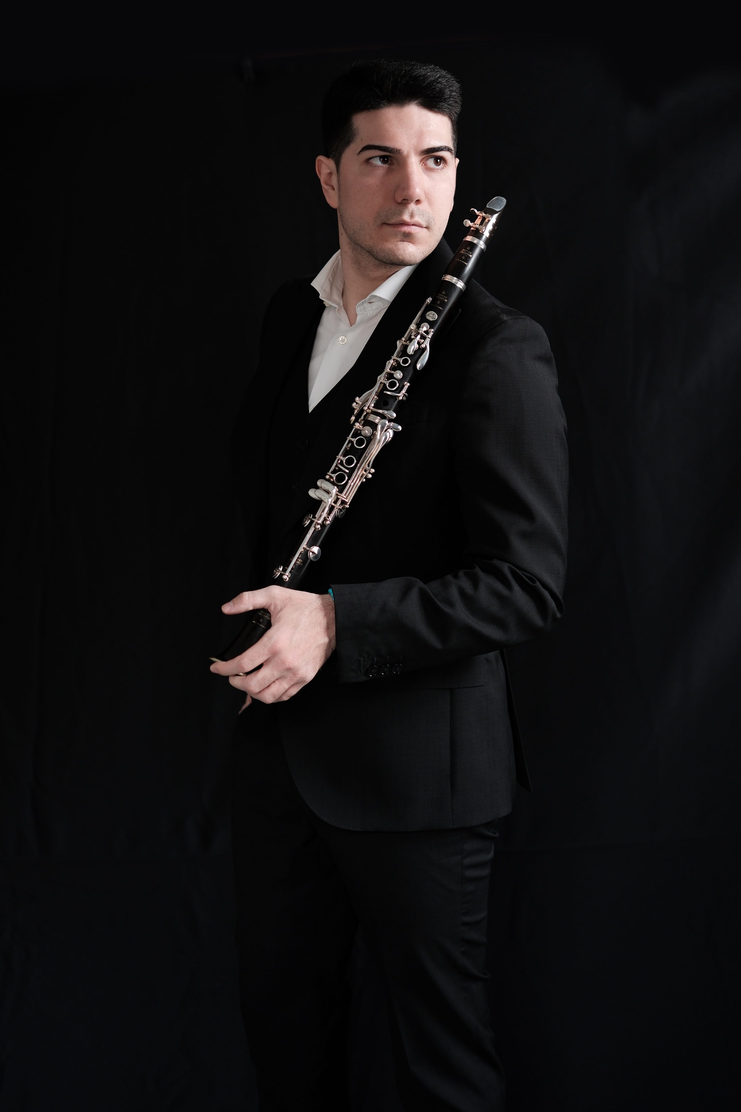

Aldo Botta (1994) is clarinet professor at the “P. I. Tchaikovsky” Conservatory of Music in Nocera Terinese - Catanzaro and principal clarinet of the Orchestra Filarmonica della Calabria.
He began studying the clarinet under the guidance of his father Renato, a clarinet professor at middle school with a musical focus, and M° Giovanni D’Auria. He graduated with the top honors at the “D. Cimarosa” Conservatory of Music in Avellino, under the guidance of M° Antonio Napolitano. He has improved under the guidance of Mº Calogero Palermo, who has been his mentor since the very beginning.

He has performed for RAI Italian TV and Radio on several occasions both as a soloist and as an orchestral (RAI1, RAI2, RAI3, RAI5, RAI RADIO3). He has undertaken numerous tours both in Italy and abroad (Japan, China, United Arab Emirates, Oman, Germany, Switzerland, Romania, Bulgaria, Greece).

He qualified for several prestigious orchestral selections including: competition for the position of principal clarinet at the Varna State Opera Orchestra (Bulgaria); audition for the position of principal clarinet at the Orchestra of the Fondazione Lirico-Sinfonica Teatro Petruzzelli of Bari; competition for the position of principal clarinet at the Istituzione musicale e sinfonica of Friuli Venezia Giulia (ICO); audition for the position of principal clarinet at the Orchestra Sinfonica del Molise (ICO); audition for the positions of clarinet and piccolo clarinet at the Orchestra Fondazione Teatro Lirico of Cagliari.
He has collaborated with numerous prestigious orchestras including those of the Teatro dell’Opera di Roma, Teatro San Carlo di Napoli, Teatro Lirico di Cagliari, Teatro Petruzzelli di Bari, Filarmonica del Teatro Comunale di Bologna, “LaFil” Orchestra Filarmonica di Milano, Orchestra Filarmonica della Calabria, Orchestra Filarmonica del Teatro “G. Verdi” di Salerno, Teatro Gesualdo di Avellino, Orchestra L. Cherubini, Orchestra Sinfonica del Molise, Accademia di Santa Sofia, Plovdiv Philharmonic Orchestra, Orchestra Bulgaria Classic, Orchestra da camera Zenit 2000, in which he had the opportunity to play with conductors such as R. Muti, Z. Mehta, Y. Abel, J. Bernacer, F. I. Ciampa, F. Arlia, M. Boni, R. Abbado, L. Quadrini, P. Nuzzo, G. Westley, P. Baleff, N. Paszkowski, M. Seco, A. Pantaneschi, S. Genuini, A. Lonquich, F. Mildenberger, V. Sinaisky, L. Hager, M. Testa, F. Petracchi, P. Connelly, C. Boccadoro.

He has recorded pieces for solo clarinet and for clarinet and piano, some of which are world premiere recordings, for international label such as: Brilliant Classics; Amadeus Records, Tactus Records; Da Vinci Classics; Aulicus Classics; Stradivarius; Movimento Classical; EMA Vinci Records; with broadcasts on Italian and foreign radio stations such as: Rai Radio 3 – Primo Movimento; TRT Radyo 3 (Türkiye).

He is the author of the following didactic texts for clarinet: “The Virtuoso Clarinet” published by Volonè&Co Music Editions; "Progressive Technique for Clarinet" published by Da Vinci Edition; "100 Staccato Exercises for Clarinet" published by Eufonia Music Editions; and the series of daily technique exercises, 750 pages in 5 books, "Il Clarinetto" published by Accademia2008 Music Editions.

